Period _________

AP Biology Date ______________________
LAB ____. LIMITS TO CELL SIZE
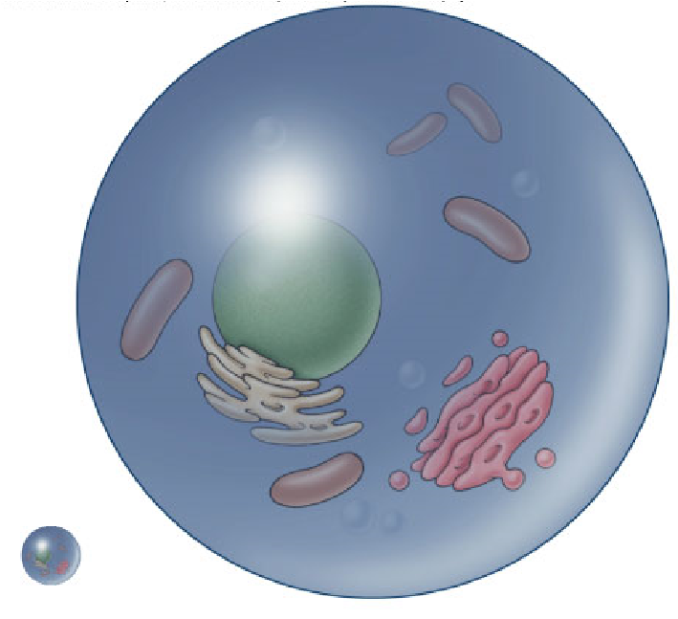
Most cells are between 2 micrometers and 200 micrometers—too small to be seen with naked eye. Remember, a micrometer is 1 millionth of a meter! Why can’t cells ever become larger than that? Why don’t we regularly find one-celled organisms the size of small multicellular animals, like frogs or even flies? In other words, why can’t there ever be an organism which is visible to the naked eye and that is one giant cell?
In order for cells to survive, they must constantly exchange ions, gases, nutrients, and wastes with their environment. These exchanges take place at the cell’s surface—across the cell membrane. The movement of these materials is accomplished mostly by diffusion (flow of solutes down a concentration gradient) across the cell membrane. Consequently, factors that affect diffusion can affect the survival of a cell.
One of the core principles that governs the efficiency of diffusion is the ratio of surface area to volume. Surface area is the amount of cell membrane available for diffusion. So for a cell, surface area actually represents how much diffusion that can happen at one time. Whereas volume is the amount of cytoplasm contained within the cell membrane. So for a cell, volume is how long It takes to get from the membrane to the center of the cell by diffusion.
Therefore, to perform diffusion efficiently, there must be an adequate ratio between the cell’s surface area and its volume. But as a sphere (the simplest model of cell shape) gets larger, its volume increases at a different rate than its surface area. In this lab, we will investigate this relationship and how it affects diffusion time.
The prime limitation to cell size is the limitation imposed by diffusion. Diffusion is a very slow process. If a cell were 20 cm (~8 inches), it would take days for nutrients to reach its center or for wastes to reach the cell membrane. The cell would quickly starve to death or poison itself with its own wastes. So what’s the solution, if a cell approaches its maximum size? It’s time to divide! If cells receive the proper signals, they will divide by mitosis before they become too big.
Materials:

Cups
Agar
Bromothymol blue
Vinegar
Ruler
Plastic knife
Scale
Ice cube tray

Cube | Surface area (cm2) | Volume (cm3) | Surface area to volume ratio | Diffusion Depth (mm) | Diffusion rate (mm/min)

2 cm

Procedure Part 1
Using a plastic knife and a ruler, cut the bromothymol blue agar block into a 2 cm cube. Place the agar cube into a cup of vinegar for 10 minutes. After 10 minutes take the cube out of the vinegar and measure the depth to which the vinegar penetrated the cube. Record the results in the data table.

PART 2 PROCEDURE
Cell Size (cm) | Surface Area | Volume | SA : V ratio | Time for  Complete  Diffusion
1 x 1 x 1
2 x 2 x 2
1 x 1 x 3
In this lab activity, you will use agar cubes as cell models. You will investigate how increasing a cell’s size affects the time for diffusion to move material across the cell. The agar for the cubes has been dyed with bromothymol blue—a pH indicator. When the agar cubes are placed in vinegar, they will begin to turn yellow as the vinegar diffuses into the agar. You will time this diffusion process for 3 different sized cells and compare them. Diffusion will be considered complete when the blue color completely disappears from the center of the cell.

PART 3 PROCEDURE
Now that you have been able to explore the relationship between cell dimensions and diffusion time, let’s see if you can put your new-found understanding to good use. Cells do come in many shapes and sizes in organisms. Natural selection has crafted them to do their jobs better with their unique form. You will find that the relationship between structure and function is a recurrent theme throughout biology.
Let’s give you the anointed role of “Intelligent Designer” for a competitive Cell Diffusion Race. Each student will get an equal size block of bromothymol blue agar and will have the opportunity to design a cell to maximize mass but minimize diffusion time. The cell with the greatest mass and the shortest diffusion time will be judged the winner.
THE CELL DIFFUSION RACE RULES:
- No donut-like holes through the agar cell—this is biologically impossible.
- Once agar cell is in beaker of vinegar, no poking, prodding, touching beaker.
- Teacher determines when 100% diffusion takes place. Diffusion will be considered complete when the blue color completely disappears from the center of the cell.
- Students mass agar at end of race and cell must not break when handled! If cell breaks upon massing, then entry is disqualified.
- WINNER = highest ratio of mass divided by time.

Team | Cell Mass (gm) | Time for Complete Diffusion (minutes) | Mass (g) / Time (min)

2

SUMMARY QUESTIONS
- Complete the chart below to investigate the relationship between surface area & volume as a cube increases in size.

Cube (cm) | Surface Area | Volume | SA : V ratio
1 x 1 x 1
2 x 2 x 2
3 x 3 x 3
As the cube increases in size, what happens to the surface area to volume ratio? Explain.
_________________________________________________________________________
_________________________________________________________________________
_________________________________________________________________________
- Which cell in Part 1 had the fastest diffusion time? ________________________________
Explain why._______________________________________________________________
_________________________________________________________________________
_________________________________________________________________________
- A 2x2x2 cell and a 1x1x8 cell have the same volume. Would their diffusion times be the same? Explain why or why not.
_________________________________________________________________________
_________________________________________________________________________
_________________________________________________________________________
- In general, what is the relationship between the SA:V ratio and diffusion time?
_________________________________________________________________________ _________________________________________________________________________
3
- Explain why cells can’t get very, very big.
_________________________________________________________________________
_________________________________________________________________________
_________________________________________________________________________
_________________________________________________________________________
- Describe your cell design. What principles were you basing your design on to decrease diffusion time?
_________________________________________________________________________
_________________________________________________________________________
_________________________________________________________________________
- Describe different ways that cell shape can be modified so that diffusion rate will be decreased to support life processes.
_________________________________________________________________________
_________________________________________________________________________
_________________________________________________________________________
- Give an example of a type of cell in a living organism (animal or plant) that is shaped very differently than the classical round or boxy shape that you see drawn in introductory textbook chapters on cells. Explain how that unique shape is tied to the function that those cells perform.
_________________________________________________________________________
_________________________________________________________________________
_________________________________________________________________________
- Which cell design won the race? Offer an idea as to why.
_________________________________________________________________________
_________________________________________________________________________ _________________________________________________________________________

Lab Notebook Guidelines
- Title
- Background information about cell size, surface area, and volume. Be detailed!!
- Purpose of the experiments
- List of materials used
- Part 1:
  - Write a hypothesis
  - Summarize procedures
  - Data table
  - Conclusion
- Part 2:
  - Write a hypothesis
  - Summarize procedures
  - Data table
  - Conclusion
- Part 3:
  - Write a hypothesis
  - Summarize procedures
  - Sketch a picture of your designed cell
  - Data table
  - Conclusion
- Answers to the summary questions

