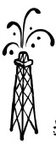
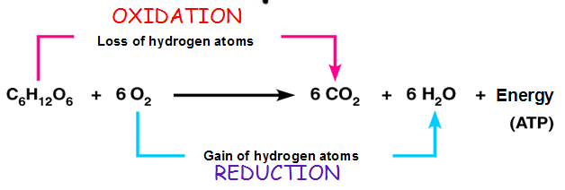
CELLULAR RESPIRATION-Chapter 9
C₆H₁₂O₆ + 6O₂ → 6 CO₂ + 6 H₂O + energy
Type of oxidation-reduction (redox) reaction
OIL RIG
Oxidation Is Losing electrons
Reduction Is Gaining electrons

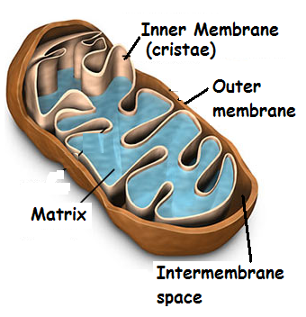

MITOCHONDRION STRUCTURE
Double membrane- allows compartmentalization
OUTER MEMBRANE
INNER MEMBRANE (CRISTAE) –contains Electron transport proteins
MATRIX- contains enzymes for KREBS CYCLE
INTERMEMBRANE SPACE- between cristae and outer membrane
Place where H⁺ ions accumulate during ETC
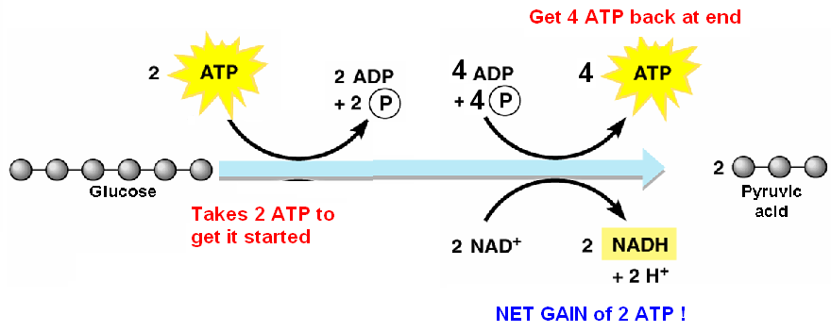
GLYCOLYSIS
“Glykos”= sweet; “lysis”=split apart
GLUCOSE → 2 PYRUVATE
Occurs in cytosol
Requires 2 ATP to get started
Produces 4 ATP (net gain 2 ATP)
Produces 2 NADH

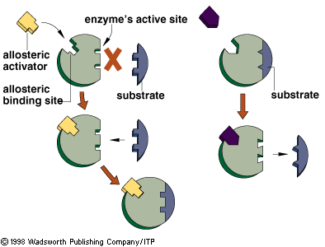
GLYCOLYSIS PATHWAY
Regulated by phosphofructokinase
ALLOSTERIC enzyme near beginning of pathway
AMP turns pathway on
(AMP is high when ATP is needed)
ATP turns pathway off
(don’t waste energy making ATP when not needed)

EVOLUTIONARY LINKS
Glycolysis = Most widespread metabolic pathway
• Earliest fossil bacteria (3.5 billion years ago) but large amounts of oxygen not present until 2.7 BYA
• Works without oxygen
~suggests ancient prokaryotes probably used glycolysis to make ATP before oxygen was present
• happens in cytoplasm without mitochondria
~ suggests it was in early prokaryotic cells before eukaryotes appeared
eukaryotes appeared 1 billion years after prokaryotes (Endosymbiotic theory)
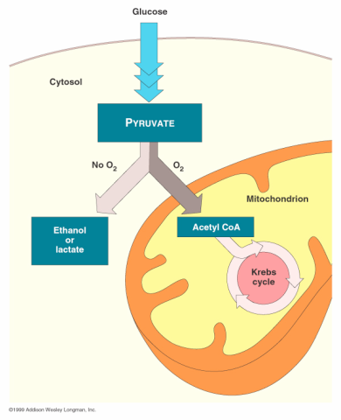
WITHOUT OXYGEN (anaerobic)
Pyruvate → FERMENTATION
Regenerates NAD+ carriers to allow glycolysis to continue

ALCOHOLIC FERMENTATION
Pyruvate → CO₂ + alcohol + NAD⁺
Used by microorganisms to make beer/wine
Used by yeast to make bread
LACTIC ACID FERMENTATION
Pyruvate → lactic acid + NAD⁺
Human muscle cells when oxygen is low during exercise
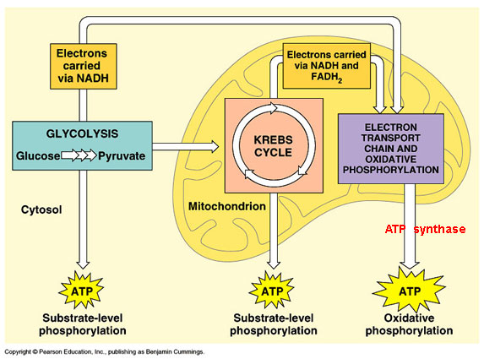
WITH OXYGEN
GLYCOLYSIS → KREBS CYCLE → ETC
HIGH ENERGY ELECTRON CARRIERS:
(B-vitamin coenzymes)
NAD⁺ → NADH FAD → FADH₂

FACULTATIVE ANAROBES (Ex: yeast/some bacteria)
can switch back and forth between fermentation/respiration
depending on O₂ availability

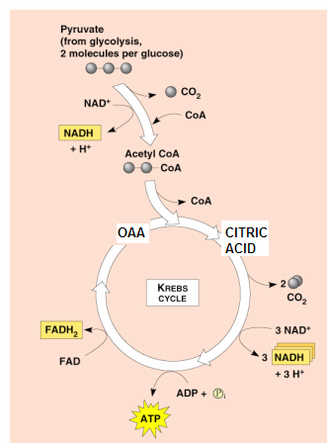
Pyruvate transported into mitochondrial matrix
Uses 1 ATP/pyruvate for active transport

ACETYL CO-A CHARGING (B-vitamin coenzyme)
Co enzyme A receives carbons from pyruvate
feeds them into Krebs cycle
Enzyme removes CO₂ from pyruvate producing Acetyl CoA
Each glucose produces 2 C0₂ + 2 NADH

KREBS (CITRIC ACID) CYCLE
Releases 6 original carbons in glucose as 6 CO₂;
Stores energy in NADH/FADH₂
Occurs in Mitochondrial MATRIX
OAA (oxaloacetic acid) receives 2 carbons from Acetyl CoA
to make CITRIC ACID
Each glucose requires TWO turns of cycle
1 GLUCOSE produces: 6 CO₂, 2 FADH₂, 2 ATP, 8 NADH

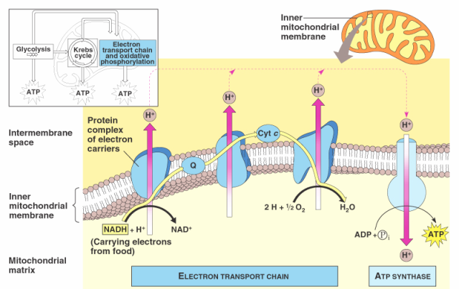
ELECTRON TRANSPORT-
stage that produces the MOST ATP
Attached to CRISTAE inner membrane
Uses energy from NADH & FADH₂ to
create proton gradient and make ATP
Includes:
THREE transmembrane PROTON PUMPS;
Carrier molecules between pumps =
UBIQUINONE (Q); and CYTOCHROMES
Each NADH makes 3 ATP (drops its electrons at top of ETC; hits all 3 proton pumps)
Each FADH₂ makes 2 ATP (drops its electrons at Q; skips 1st proton pump; so makes less ATP)
Electrons passing down ETC provide energy for pumping H⁺ ions into INTERMEMBRANE SPACE
Final electron acceptor at end of ETC = O₂ (O₂ + 2e- +2H⁺ → H₂O)
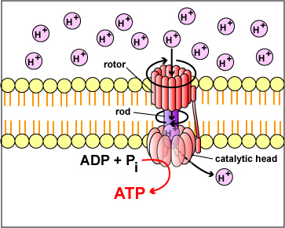
1 glucose yields 36 net ATP

Proton gradient powers ATP SYNTHASE to ADP + P_{i} → ATP
PROTON MOTIVE FORCE = potential energy of hydrogen ion gradient
CHEMIOSMOSIS = Generation of ATP from a proton gradient
(It occurs in all living things)

OXIDATIVE PHOSPHORYLATION using proton gradient created by electron transport chain in cristae membrane to make ATP
ETC + CHEMIOSMOSIS = OXIDATIVE PHOSPHORYLATION
SUBSTRATE LEVEL PHOSPHORYLATION (found in glycolysis & Krebs cycle)
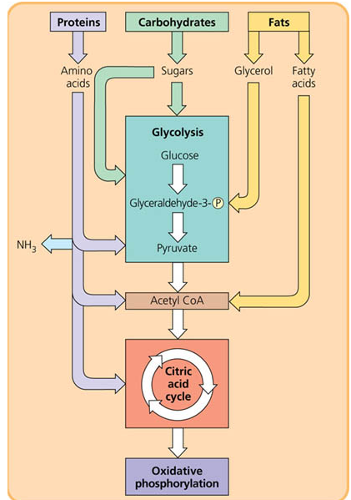
Addition of phosphate group directly WITHOUT proton gradient and ATP synthase
OTHER FUEL MOLECULES
Fats, proteins, carbohydrates can be broken down to release energy
1 g of fat → twice as much ATP as 1 g of carbohydrate

BETA OXIDATION = breakdown of fatty acids into 2 carbon fragments
can enter Krebs cycle as acetyl CoA
Intermediates from glycolysis and Krebs cycle can be diverted into anabolic pathways to provide building blocks for many macromolecules



