CHAPTER 23 & 24 POPULATIONS AND SPECIES
POPULATION- localized group of individuals capable of interbreeding
GENE POOL- All the alleles in a population
SPECIES= = group of organisms that can interbreed with one another and produce viable fertile offspring
Different species can’t produce fertile offspring
EX: Horse X donkey → mule; lion X tiger → liger
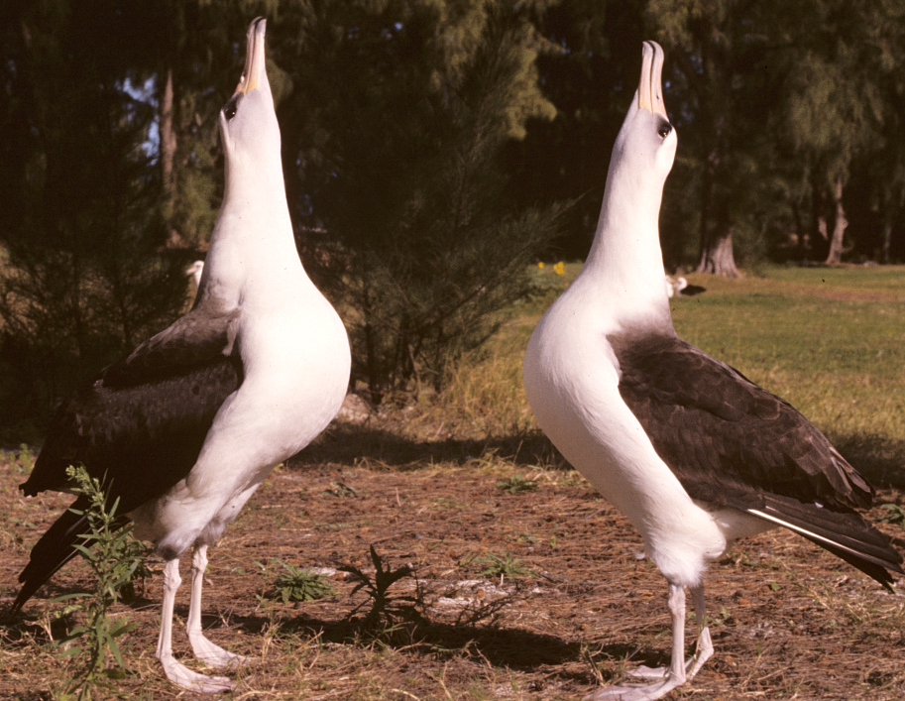
WHAT PREVENTS INTERBREEDING AND KEEPS SPECIES SEPARATE?
1) REPRODUCTIVE BARRIERS:
PREZYGOTIC BARRIERS – Impede mating or hinder fertilization
HABITAT ISOLATION-
“COMPETITIVE EXCLUSION PRINCIPLE”
= each species occupies a specific niche
May not contact each other even if live in same area
BEHAVIORAL ISOLATION
signals/behaviors used to attract mates differ
EX: visual (firefly), auditory (crickets);
pheromones; mating “dances”

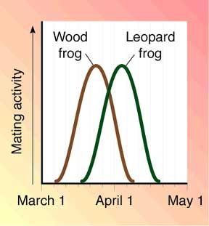
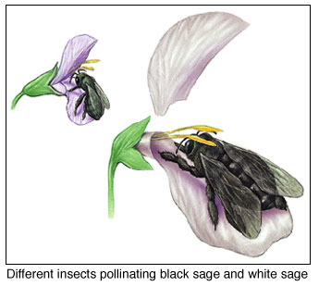
TEMPORAL ISOLATION
Breed during different times of day, seasons, or different years

MECHANICAL ISOLATION
Size and shape of reproductive organs anatomically incompatible

GAMETIC/GENETIC ISOLATION
= gametes are incompatible
Sperm can’t survive in female reproductive tract
OR not recognized by egg receptors
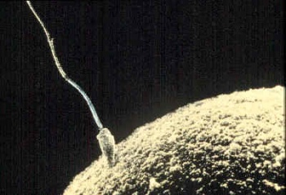

POSTZYGOTIC BARRIERS - After mating
ZYGOTE DIES
fertilized egg doesn‘t develop
Offspring is INFERTILE (can’t reproduce)
EX: Horse (64 chromosomes) X donkey (62 chromosomes)
→ mule (63 chromosomes)
EX: POLYPLOIDY (3n, 4n, 6n . . .)
• Can’t interbreed with the parent/
• Can self-fertilize or mate with other “ploids”

2) GEOGRAPHIC BARRIERS
• Gene pool of a population is separated/split
Ex: Island, lake, mountain top, retreating water, fire separating populations of grasslands,
seed blown to new region by storm, lake drying up
• Allows change in gene pool provided that each population has selection taking place

REPRODUCTIVE/GEOGRAPHIC BARRIERS
SYMPATRIC SPECIATION “same country”
• REPRODUCTIVE BARRIER within population
EX: POLYPLOIDY
• Can’t interbreed with the parent
• Can self-fertilize or mate with other “ploids”
• can lead to SPECIATION: formation of new species
• too many changes make interbreeding impossible
ALLOPATRIC SPECIATION “other country”
• GEOGRAPHIC barrier blocks gene flow

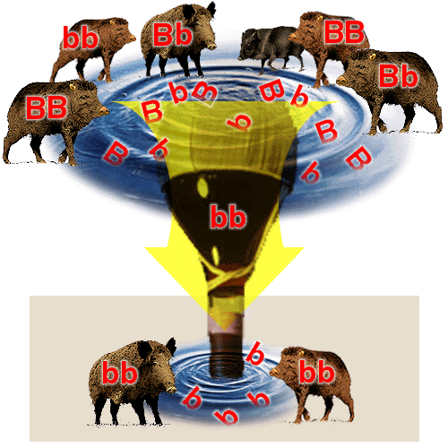
MACROEVOLUTION (fish → amphibians; dinosaurs → birds)
• change above species level
MICROEVOLUTION- (bacteria → different bacteria; fish → different fish)
• changes within a gene pool (species level)
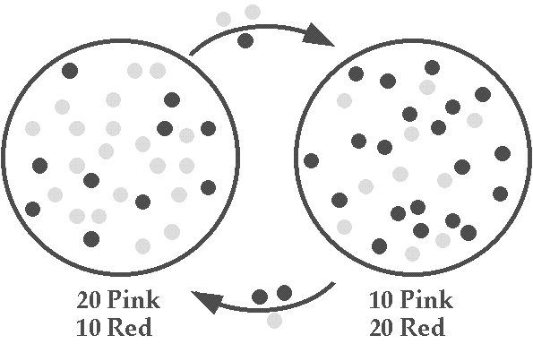
• Most creationists accept evidence for microevolution
5 CAUSES OF MICROEVOLUTION
1) GENETIC DRIFT random changes in small gene pools DUE TO CHANCE NOT natural selection
EX: BOTTLENECK EFFECT- disaster drastically reduces size/genetic variation of population
survivors determined by chance (Ex: flood, overhunting)
EX: FOUNDER EFFECT- small subgroup moves to new area
“Blue skinned people” in Appalachia

2) GENE FLOW:
The movement of alleles into and out of a gene pool
Mixing tends to reduce differences between populations
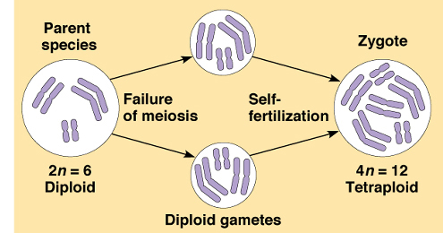

3) MUTATIONS = introduce new alleles to gene pool
important source of variation for natural selection to act upon
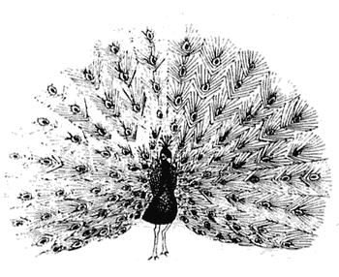
POLYPLOIDY- (3n, 4n, 6n, 8n) not common in animals
- Common in plants (40-80% of all plant species?)
- rapid growth/abundant fruit production = hybrid vigor
EX: Strawberries, banana, potato, watermelon, pansies, chrysanthemums, wheat, kiwi, cotton, tobacco

4) NONRANDOM MATING- Everyone doesn’t have an equal chance to “get a partner”
Inbreeding- mate more frequently with close individuals than distant ones
SEXUAL SELECTION - Favors traits with no advantage for survival
other than fact that males/females prefer them
Leads to pronounced differences between sexes = SEXUAL DIMORPHISM
KIN SELECTION- favors altruistic behavior that enhances reproductive success
of relatives
EX: Bird that calls to warn others is in danger of being eaten, but does it anyway.

5) NATURAL SELECTION
Alleles for traits that provide survival/reproductive advantage are selected for; increase in population
FITNESS- = REPRODUCTIVE SUCCESS measured by number of offspring
relative contribution an individual makes to the gene pool of the next generation
HETEROZYGOTE ADVANTAGE “Survival of the sickest”
Deleterious alleles are maintained in population because heterozygous condition has benefit
EX Sickle cell: aa = sickle cell disease Aa- protected against malaria
Finding more and more such links – osteoporosis/TB; cystic fibrosis/cholera
Hardy-Weinberg Theorem: = NULL HYPOTHESIS
Used to determine if population is evolving
All conditions rarely met in actual populations
No change in gene frequencies = NO evolution happening
Populations is said to be in H-W EQUILIBRIUM
- LARGE population
p + q = 1
p² + 2pq + q² = 1
p = frequency of dominant allele
q = frequency of recessive allele
q² = frequency of homozygous dominant
2pq = frequency of heterozygote
p² = frequency of homozygous recessive
- NO GENE FLOW in or OUT
- NO MUTATIONS
- NO NATURAL SELECTION
- RANDOM MATING

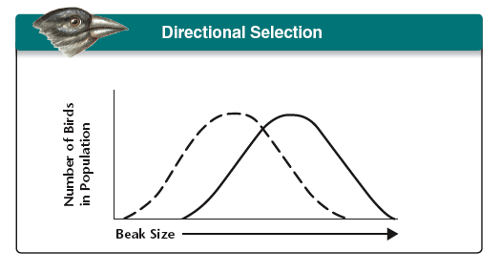 | 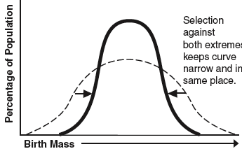 | 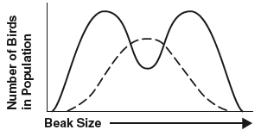
DIRECTIONAL SELECTION | STABILIZING SELECTION | DISRUPTIVE SELECTION

DIVERGENT EVOLUTION (ADAPTIVE RADIATION)
closely related species becoming more different in response to changes in environment
EX: Darwin’s finches and tortoises on Galapagos
CONVERGENT EVOLUTION
Unrelated species becoming more alike because they live in same type of environment
EX: Whales (mammals), penguins (birds), and sharks (fish) all have streamlined bodies

COEVOLUTION
Different organisms in symbiotic relationships evolve together
EX; Insects and flowers
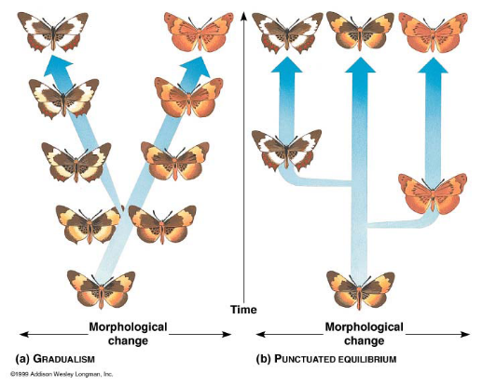
HOW FAST DOES SPECIATION OCCUR?
No debate about whether evolution happens . . .
some debate over mechanism
GRADUALISM-
• Proposed by Darwin
• Evolution proceeds slowly at a constant rate
• Many small differences accumulate over time

PUNCTUATED EQUILIBRIUM-
• Proposed by Niles Eldredge and Stephen Jay Gould
• Species diverge in spurts of rapid speciation separated by
long periods without change
• Due to rapid changes in environment
EX: MASS EXTINCTION

